**Dynamic Pricing:**

To start an article/blog about Dynamic Pricing

* *Dynamic pricing is like a chess game, where businesses make strategic moves based on market dynamics to outmanoeuvre competitors.*
* *Dynamic pricing is like surfing the waves of market demand, where businesses ride the crest of high demand and navigate the troughs of low demand to stay afloat and thrive.*
* *Dynamic pricing is the dance of supply and demand on the economic stage, where businesses twirl prices like partners in a tango, constantly adjusting their steps to maintain rhythm and harmony.*
* *Dynamic pricing is the art of culinary fusion in the marketplace, where businesses blend ingredients of consumer behaviour, competitor actions, and market trends to create a recipe for success.*

1. Amazon excels in Dynamic Pricing: **The current ruler of Dynamic Pricing in the market!**

*Amazon excels in dynamic pricing by leveraging vast data analytics, algorithms, and real-time adjustments. It monitors demand, competitor pricing, and market conditions to optimize prices for maximum profitability. While effective, this strategy has raised concerns about price discrimination and fairness among customers. Amazon's mastery of dynamic pricing ensures its continued dominance in the e-commerce landscape*.

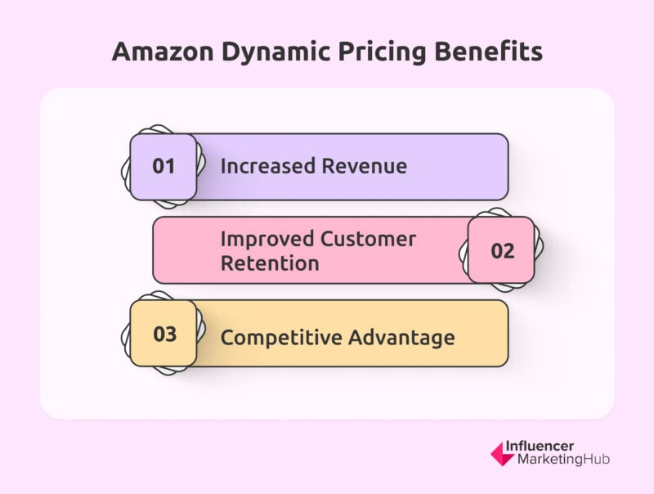

1. What is Dynamic Pricing?
2. Dynamic Pricing examples. 1-2 can be given of the Uber/Ola pricings of how they have adopted this strategy to gain profits as well as suit customer preferences.

*To understand the concept of Dynamic Pricing better, we can take help of examples. The first example shows the fluctuation of prices of hotels at different phases of the year that in turn is responsible for the demand and price surge. The second example is taken from the seat tickets of IPL. We note that the price of tickets is at a peak in the Opening Match and Finals compared to the usual matches of IPL.*

***a****) Customers pay prices set by platforms like Booking.com or Airbnb, which fluctuate based on demand and other factors. Whether it's a holiday weekend, a major event in town, or simply high demand for accommodations, the prices of hotel rooms can vary through dynamic pricing.*

*One reason dynamic pricing works well for these platforms is because it* ***helps incentivize hosts to make more rooms available*** *in popular areas by adjusting their rates accordingly.*

*Another benefit is that it helps manage demand and reduces wait times for customers. If prices are high during peak travel seasons or events, some customers might choose to book elsewhere or wait for prices to drop before making a reservation.*

***b)*** *In cricket matches held in India, particularly during prestigious events like the Indian Premier League (IPL), dynamic pricing is commonly observed. For instance, during* ***the IPL finals, ticket prices often surge significantly*** *due to the heightened demand and excitement surrounding the match. Fans are willing to pay premium prices to witness the culmination of the tournament, resulting in higher ticket costs.*

*On the other hand, for* ***regular league matches*** *in the IPL, ticket prices are typically set at a* ***more nominal rate****. The pricing may vary depending on factors such as the popularity of the teams playing, the venue capacity, and the stage of the tournament. However, during these matches, organizers aim to strike a balance between maximizing attendance and revenue generation while keeping tickets affordable for fans.*

*This dynamic pricing strategy allows match organizers to capitalize on the high demand for tickets during crucial matches like the finals while also ensuring accessibility to matches throughout the tournament for a diverse range of fans.*

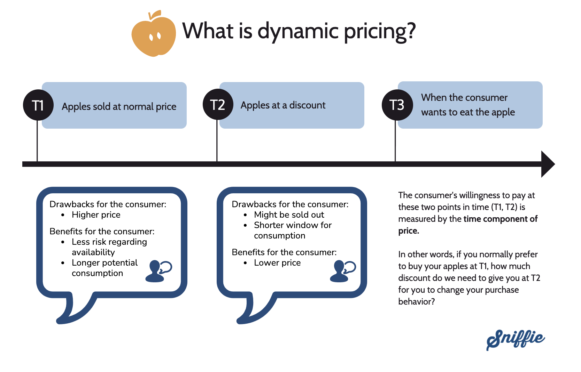

1. Why is it gaining grounds now?

Better market overview

Increase in revenue.

Get to know your customers.

More control over your pricing strategy

More precise, SKU level prices

Faster response to demand fluctuations

Customer’s price perception, leading to long terms increases in sales or profits.

More positive impact on revenue.

1. What is the logic behind Dynamic Pricing?
2. What are the main objectives that give an edge to Dynamic Pricing?

*Dynamic pricing is a strategy that bases products or services’ prices on evolving market trends, such as:*

* *Supply and demand.*
* *Competitor pricing*
* *Inventory levels.*
* *Consumer behaviour*
* *Seasonality*
* *Economic conditions*
* *time of day*
* *location-based demand*
* *customer browsing history.*
* *purchase patterns.*
* *product lifecycle stages*
* *KVIs (Key Value Items)*
* *SKUs*

*Each point can be explained for the ease of the reader in the article.*

1. What are the downsides of Dynamic Pricing? How to overcome these challenges?

***Challenges:***

* *When retailers adopt dynamic pricing solutions, whether they're ready-made or custom-built by third-party vendors, they often face what's known as the* ***"black box" dilemma****. one of the end users really understand the inner workings of the algorithms driving these tools.*
* *These algorithms analyse data and generate pricing recommendations, which sometimes deviate significantly from current retail prices.*
* *The pricing team ends up* ***rejecting these recommendations*** *altogether because they* ***lack trust*** *in their accuracy.*
* *Risk of starting a* ***price war****: Varying prices too much can lead to disruption in the market.*
* *Can be* ***time consuming****: Changing the prices so much would require* ***more labour****.*
* *Chances of* ***errors increases****!*

***To overcome these challenges:***

* ***To build trust****, it's important to* ***customize*** *every part of the solution, even how it's put into action.*
* *A dynamic pricing solution should work* ***well for category managers and pricing managers****. They should help develop, improve, and introduce the tool, and have the power to change pricing recommendations when needed. This involvement is key for businesses to see real and lasting results, like sales going up by 2 to 5 percent and margins increasing by 5 to 10 percent. Plus, customers will be happier because they'll feel like they're getting better deals on the most competitive items.*

1. Steps in establishing Dynamic Pricing?

***Flexibility matters a lot.***

*The steps you need to take to implement effective dynamic pricing.*

***1. Introduce price differentiation - two prices are better than one:*** *Price differentiation means pricing the same products or services differently based on the client's preference. A business will do this to make the most of the different financial demographics of clients.*

***2. Ensure you're using a proper value metric:*** *Value metrics refer to how you cost an item or service. Coming up with a*[*value metric*](https://www.paddle.com/blog/outcome-based-value-metrics-for-growth)*for a physical product is much more complex than coming up with a value metric for an online service, since with online services, you can split up the way you value your services.*

***3. Utilize time in an auction-type model:*** *You can ensure your products or service costs go up or down depending on time.*

***4. Couponing and discounts:*** *You can use coupons and discounts to effectively provide a dynamic price to your customers. You can especially use coupons if you are providing online services. However, it's important to limit coupon over-usage as it can devalue your brand and product over time.*

***5. Be upfront and transparent:*** *To boost revenue and customer satisfaction, you must be upfront with your clients if you are employing dynamic pricing. Being transparent about your pricing strategies helps your clients feel appreciated and not left out.*

*Ref:* [Dynamic pricing strategy: Definition, types, benefits & examples (paddle.com)](https://www.paddle.com/resources/dynamic-pricing-model#fair)

1. What are the models of Dynamic Pricing that can be employed? Can add pictures as well. Reference can be taken from the ones present in the McKinsey Article of Dos and Don’ts of Dynamic Pricing
2. Types of Dynamic Pricing?
   * + 1. Dynamic pricing based on groups.
       2. Dynamic pricing based on time.
       3. Cost-plus pricing.
       4. Competitor-based pricing
       5. Value-based pricing (price elasticity)
       6. Price skimming
       7. Bundle pricing.
       8. Penetration pricing

Ref taken from: [Dynamic pricing strategy: Definition, types, benefits & examples (paddle.com)](https://www.paddle.com/resources/dynamic-pricing-model#fair)

**More research can be done on these topics.**

1. How is Dynamic Pricing strategy better than the other models already present in the market?
2. What is the outcome of Dynamic Pricing?
3. How can EXL help you in Dynamic Pricing?
4. Famous quotes by great men which show the importance of Dynamic Pricing for retail in this fast-paced world.

* "Pricing is actually a pretty simple and straight forward thing. Customers will not pay literally a penny more than the true value of the product." - Ron Johnson
* "Dynamic pricing enables companies to respond quickly to changes in the market environment and optimize revenue by adjusting prices based on demand fluctuations." - Dr. Z. John Zhang, Professor of Marketing at the Wharton School, University of Pennsylvania.
* "Dynamic pricing enables companies to respond agilely to market fluctuations, driving profitability and sustaining competitive advantage in an ever-evolving business landscape." - Anand Swaminathan, Senior Partner at McKinsey & Company.

1. References can be added.

[models of dynamic pricing - Search Images (bing.com)](https://www.bing.com/images/search?q=models+of+dynamic+pricing&form=HDRSC4&first=1)

[Dynamic Pricing: What It Is & Why It's Important | HBS Online](https://online.hbs.edu/blog/post/what-is-dynamic-pricing)

[How retailers can drive profitable growth through dynamic pricing | McKinsey](https://www.mckinsey.com/industries/retail/our-insights/how-retailers-can-drive-profitable-growth-through-dynamic-pricing)

[Three Rules for Building the Modern Retail Organization | Bain & Company](https://www.bain.com/insights/three-rules-for-building-the-modern-retail-organization/)

[The dos and don’ts of dynamic pricing in retail | McKinsey](https://www.mckinsey.com/capabilities/growth-marketing-and-sales/our-insights/the-dos-and-donts-of-dynamic-pricing-in-retail)

[Retailers, Are You Getting the Full Value of Your Dynamic Pricing Strategy? | Bain & Company](https://www.bain.com/how-we-help/retailers-are-you-getting-the-full-value-of-your-dynamic-pricing-strategy/#:~:text=Though%20the%20term%20dynamic%20pricing%20refers%20to%20a,in%20response%20to%20relevant%20internal%20and%20external%20changes.)

[How Dynamic Pricing Strategy Can Help Retailers - Increff](https://www.increff.com/how-dynamic-pricing-strategy-can-help-retailers/)

[How retailers can drive profitable growth through dynamic pricing | McKinsey](https://www.mckinsey.com/industries/retail/our-insights/how-retailers-can-drive-profitable-growth-through-dynamic-pricing)

[Dynamic Pricing: The Complete Guide (hubspot.com)](https://blog.hubspot.com/sales/dynamic-pricing)

[Discrete Dynamics in Nature and Society (researchgate.net)](https://www.researchgate.net/journal/Discrete-Dynamics-in-Nature-and-Society-1607-887X)

[Top 5 Methods for Doing Dynamic Pricing the Right Way (growbydata.com)](https://growbydata.com/top-5-methods-for-doing-dynamic-repricing-the-right-way/)

[Dynamic pricing strategy: Definition, types, benefits & examples (paddle.com)](https://www.paddle.com/resources/dynamic-pricing-model#fair)

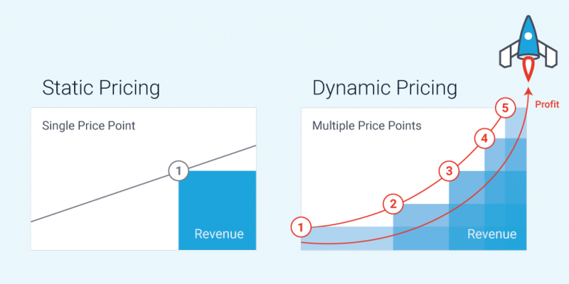

Similar diagrams can be created to demonstrate Dynamic Pricing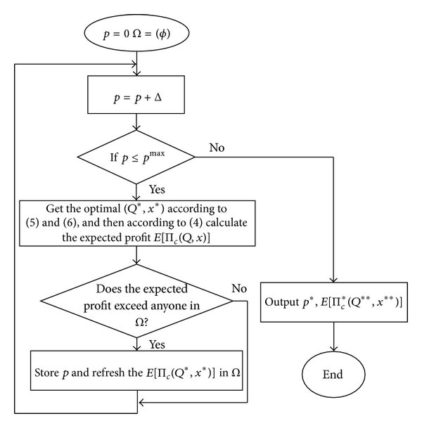

*Fig: Algorithm explaining Dynamic Pricing.*

Next in line:

1. Going through the research paper that explains this algorithm better.
2. Understanding more about different types of models and varieties of Dynamic Pricing.
3. <https://mspace.lib.umanitoba.ca/server/api/core/bitstreams/dcd38db7-8cd6-416b-b57c-ecacbe0d9f26/content> IMPORTANT PDF
4. [Kosonen_Elena.pdf (theseus.fi)](https://www.theseus.fi/bitstream/handle/10024/337798/Kosonen_Elena.pdf?sequence=2&isAllowed=y)

[pubsonline.informs.org/doi/abs/10.1287/mnsc.1120.1564](https://pubsonline.informs.org/doi/abs/10.1287/mnsc.1120.1564)

[Cross-elasticity and SKU price differentiation in dynamic pricing | by PricingHUB | Medium](https://pricinghub.medium.com/cross-elasticity-and-sku-price-differentiation-in-dynamic-pricing-7d0402d6ba61)